**Mobile Testing :-**

**Download :-**

[Download Android Studio and SDK tools  |  Android Developers](https://developer.android.com/studio?gclid=CjwKCAiAv_KMBhAzEiwAsrX1C9R99aY2edoD7zNrqLUb3fmVbNLdeqaFFXujB4H-lTTVKNMdlmeGRoCxLUQAvD_BwE&gclsrc=aw.ds)

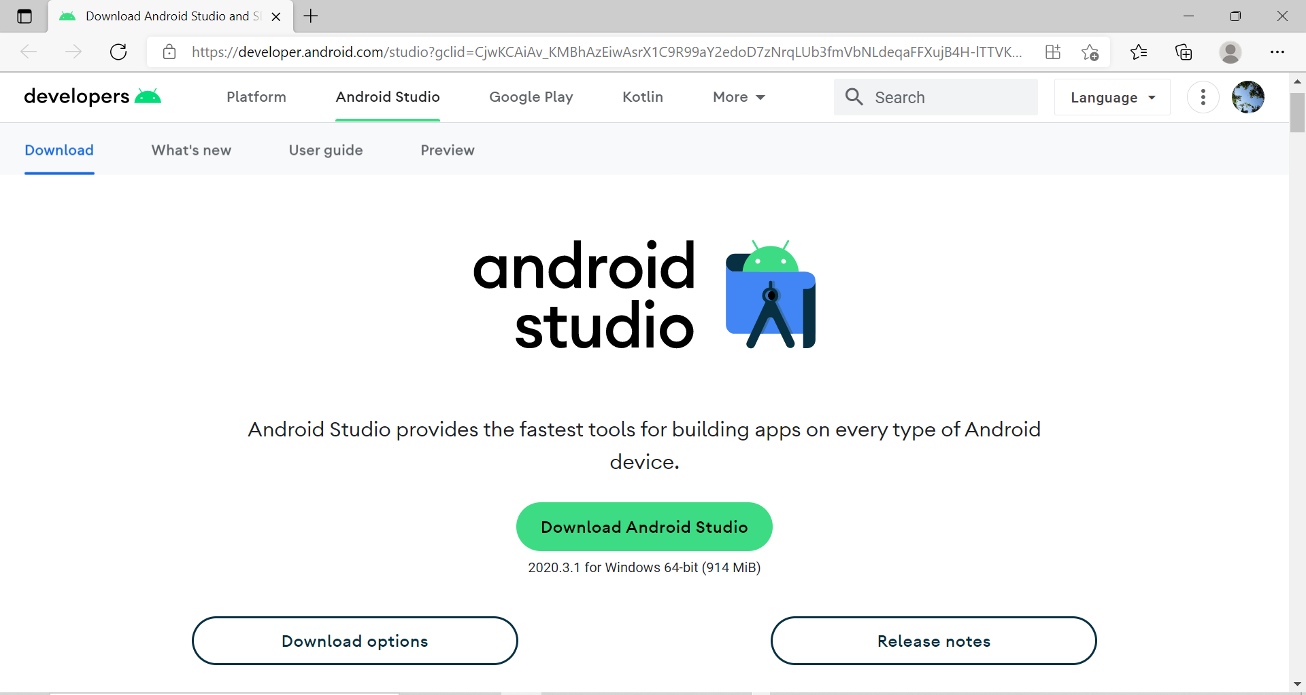

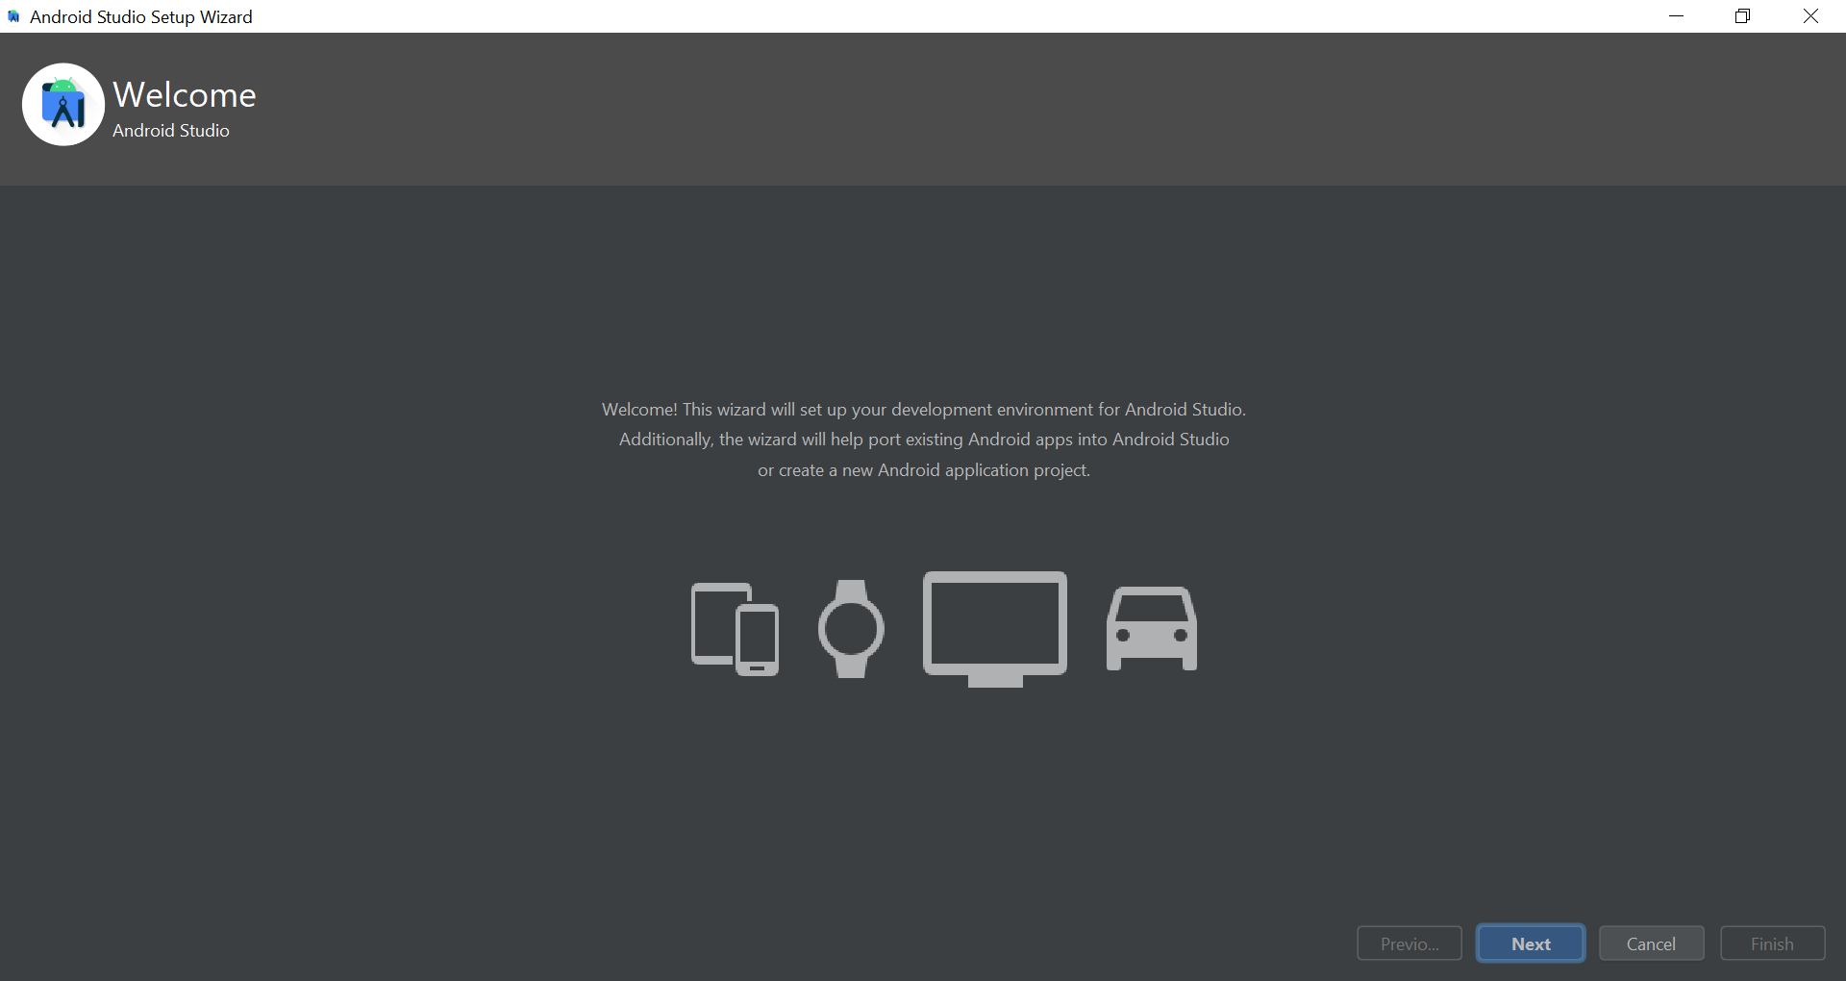

* Next

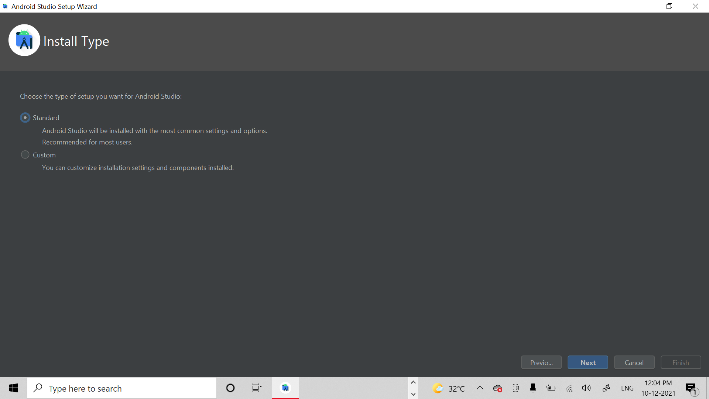

* Next

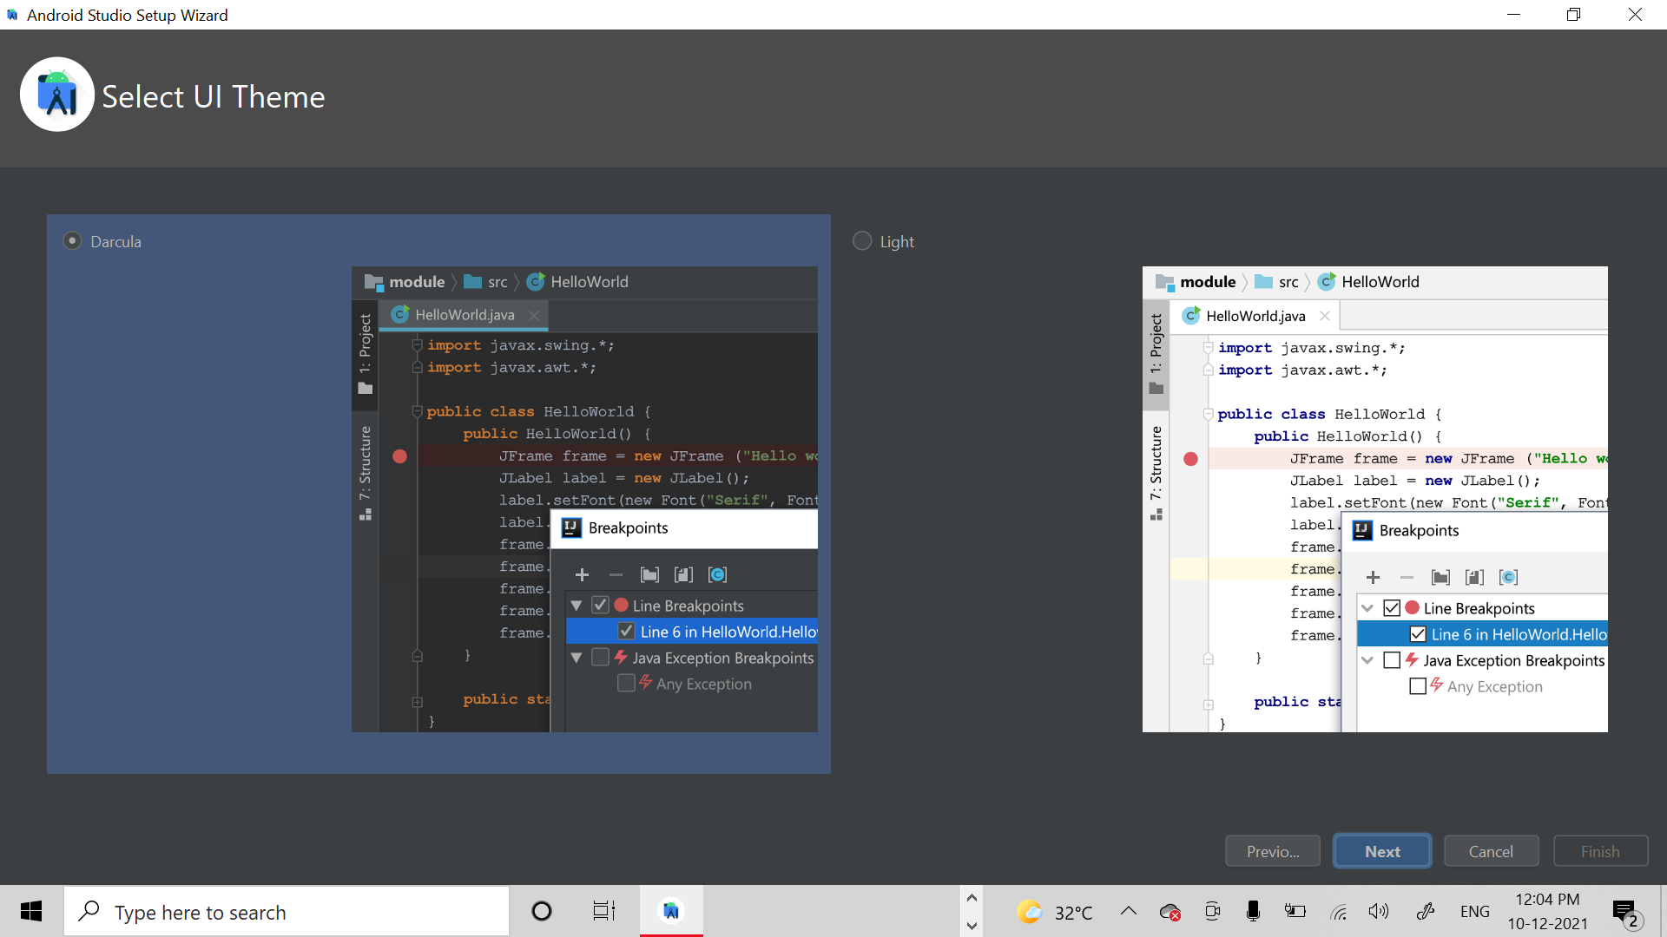

* Next

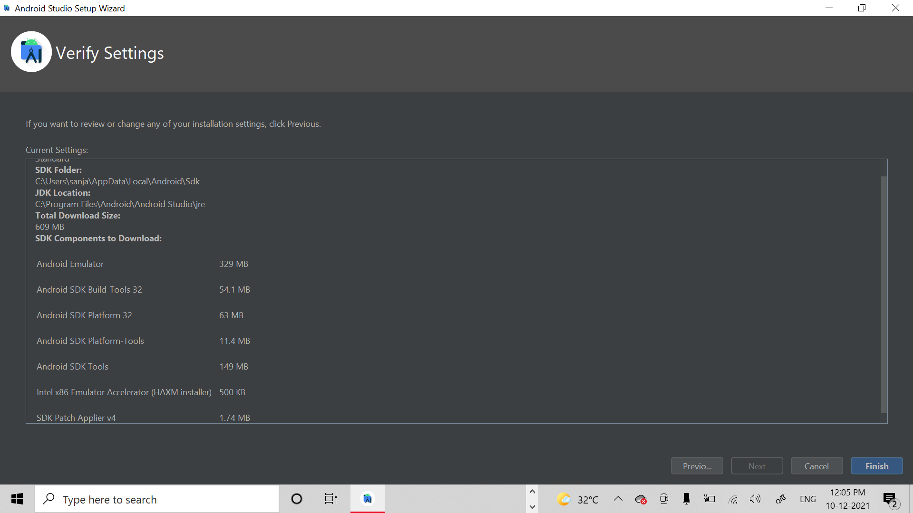

* Finish

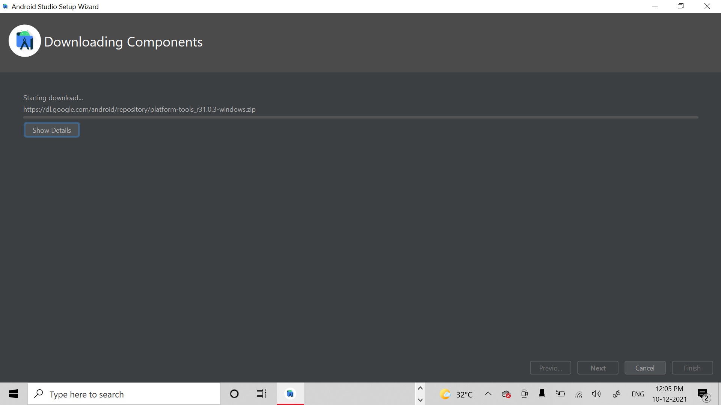

* Next

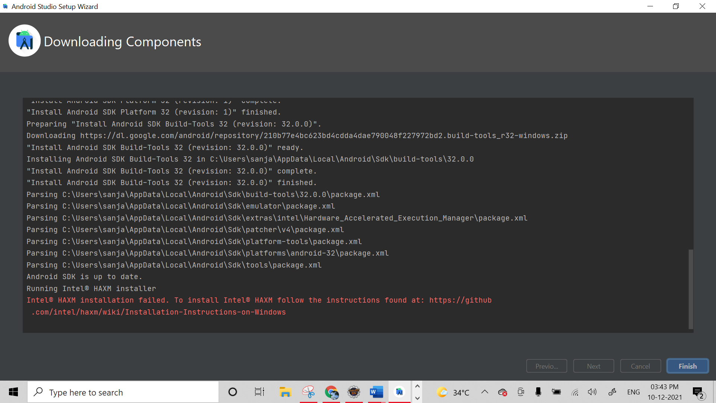

* Finish

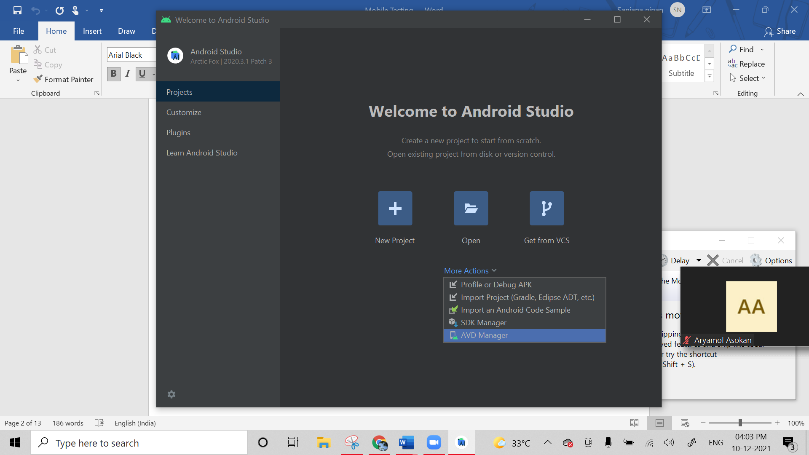

* More Actions -> AVD Manager

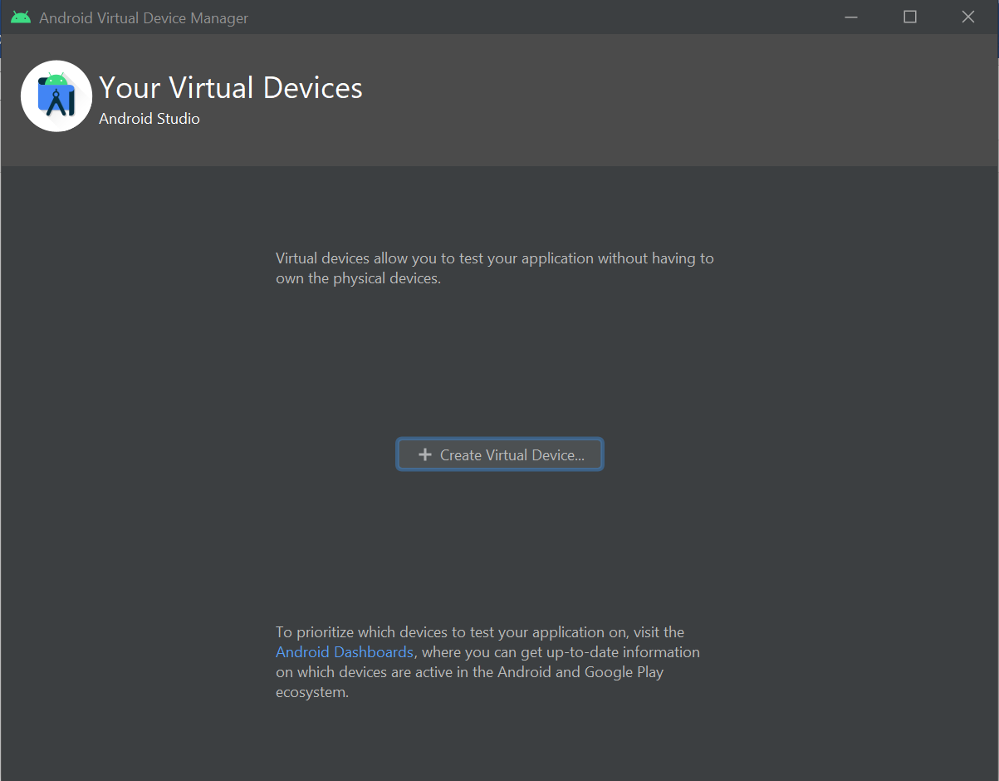

* Create Visual Device

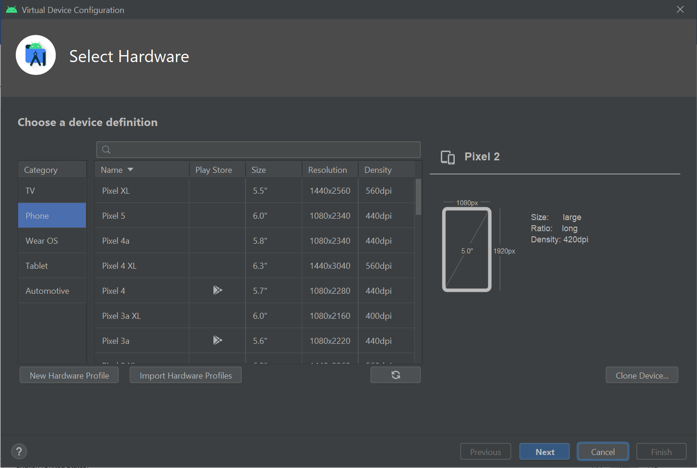

* Next

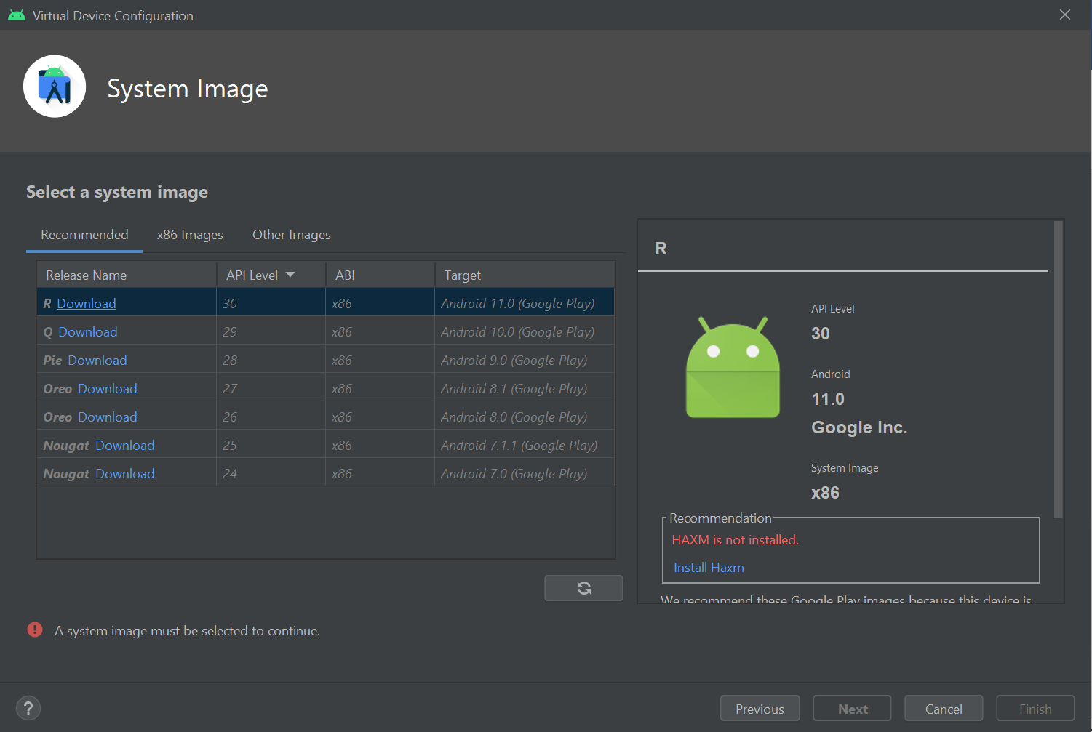

* On Q download

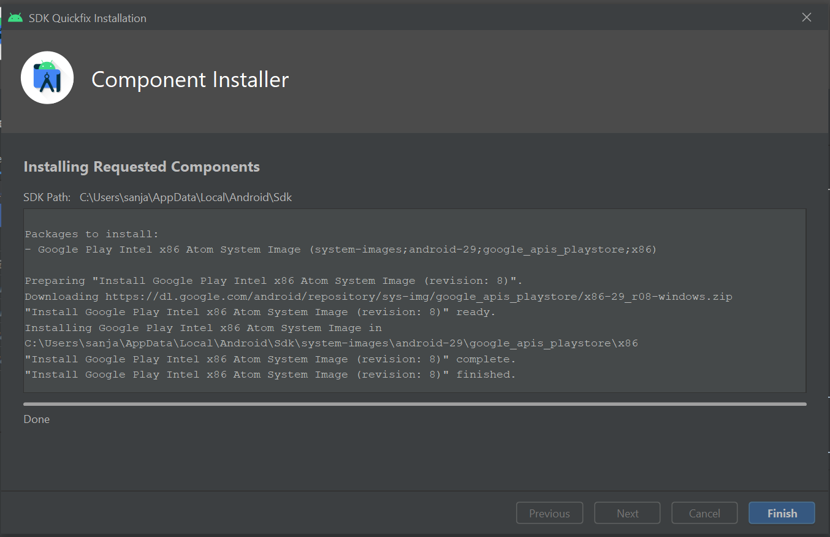

* Finish

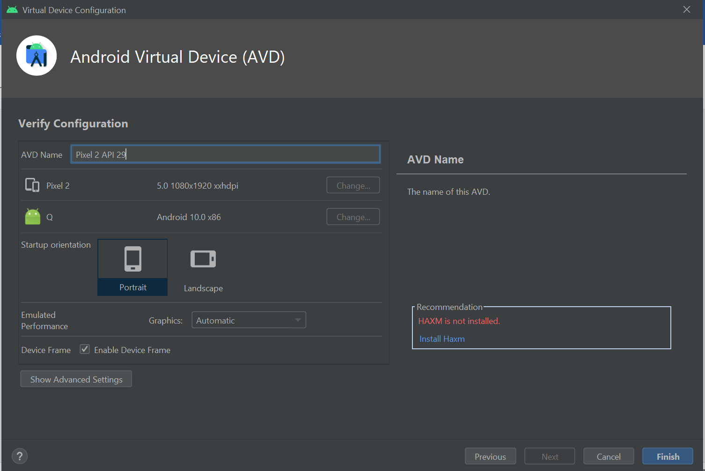

* Finish

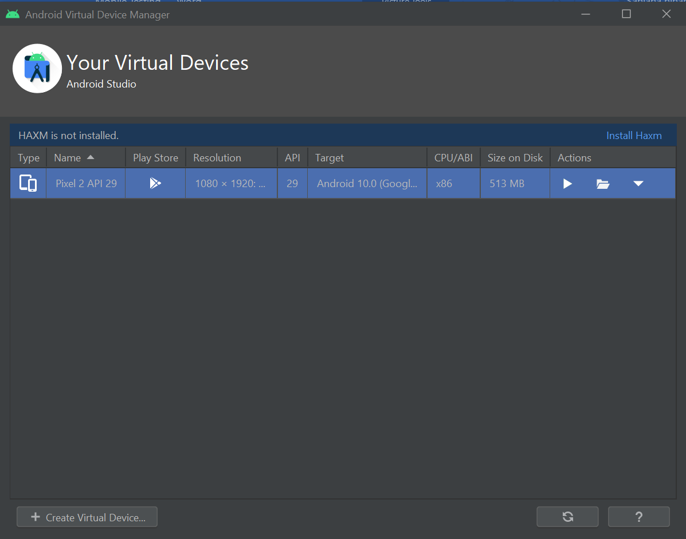

* Installing HAXM

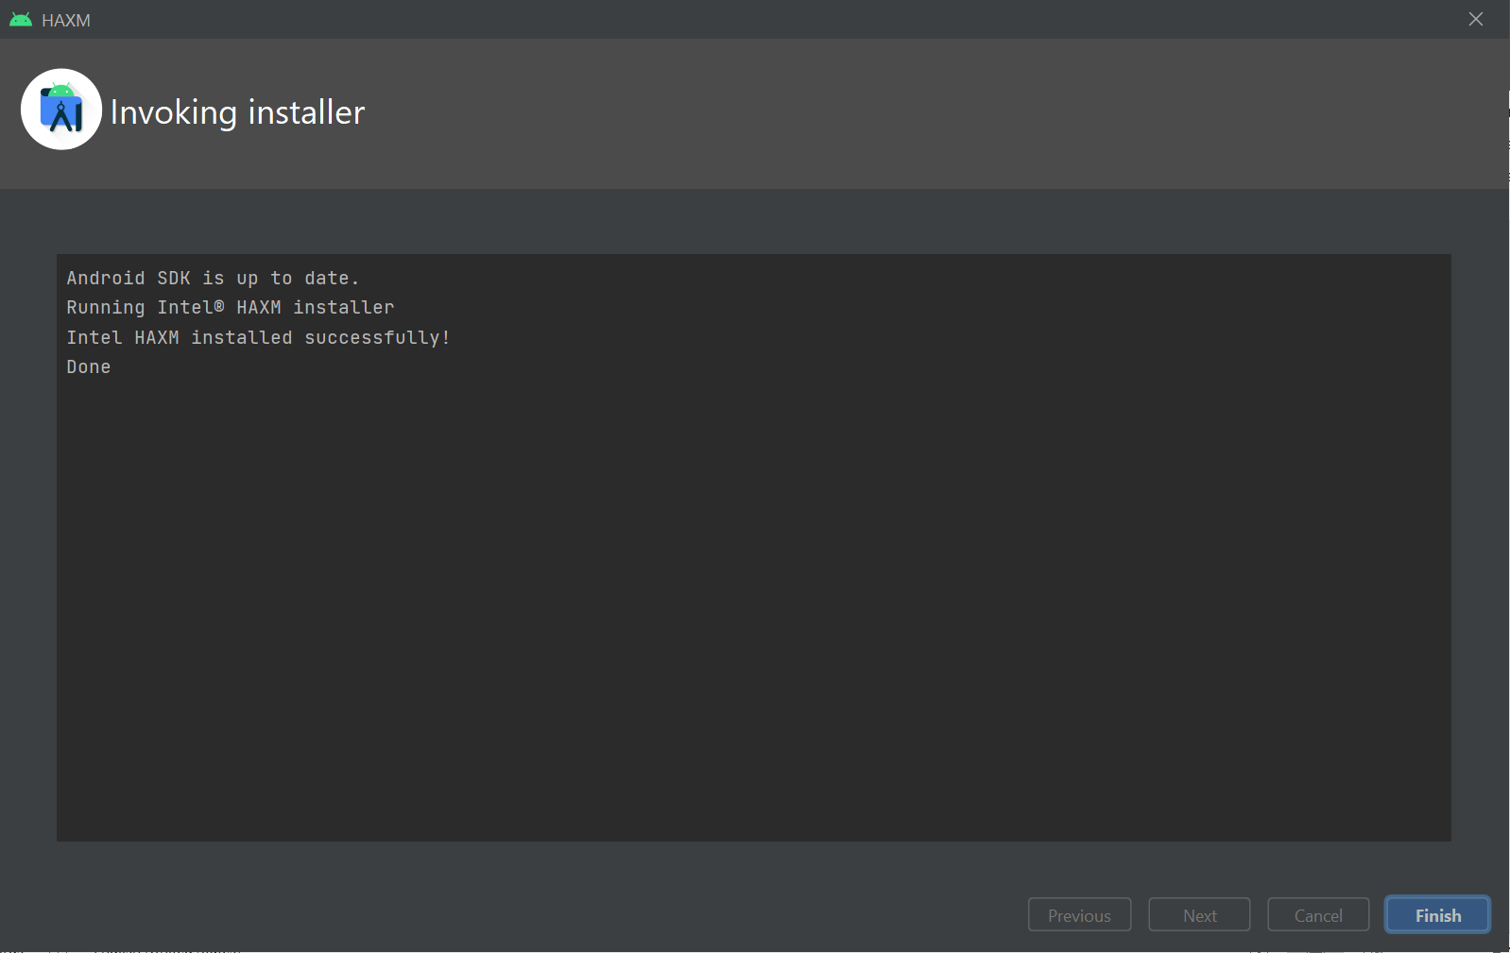

* Pressing the Actions Button

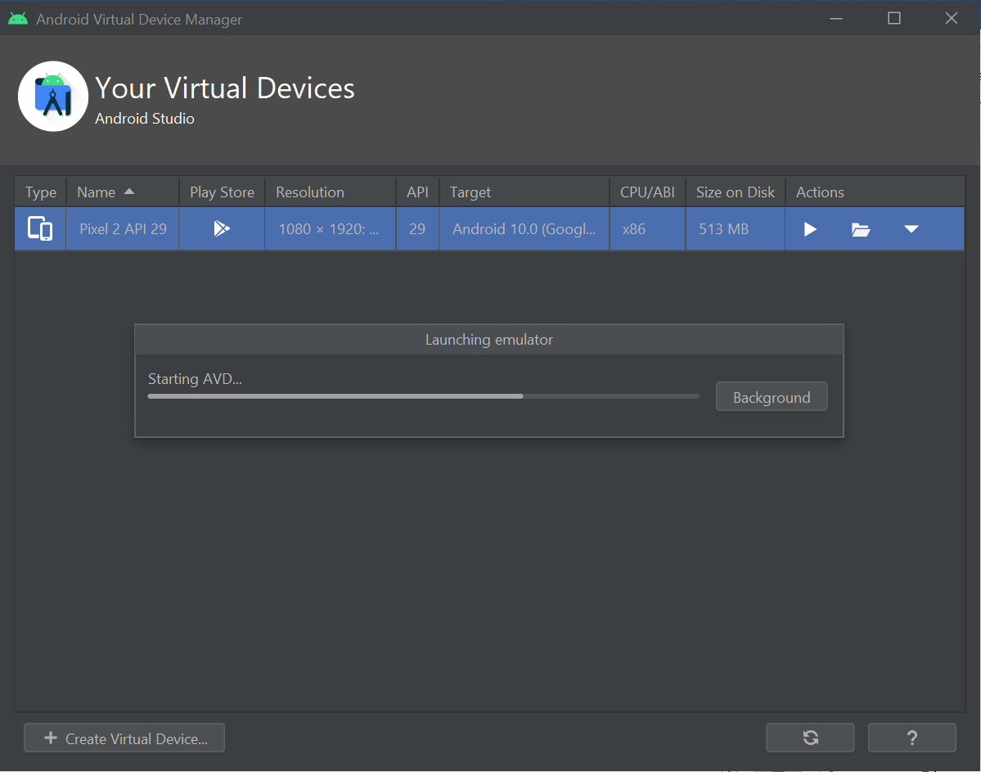

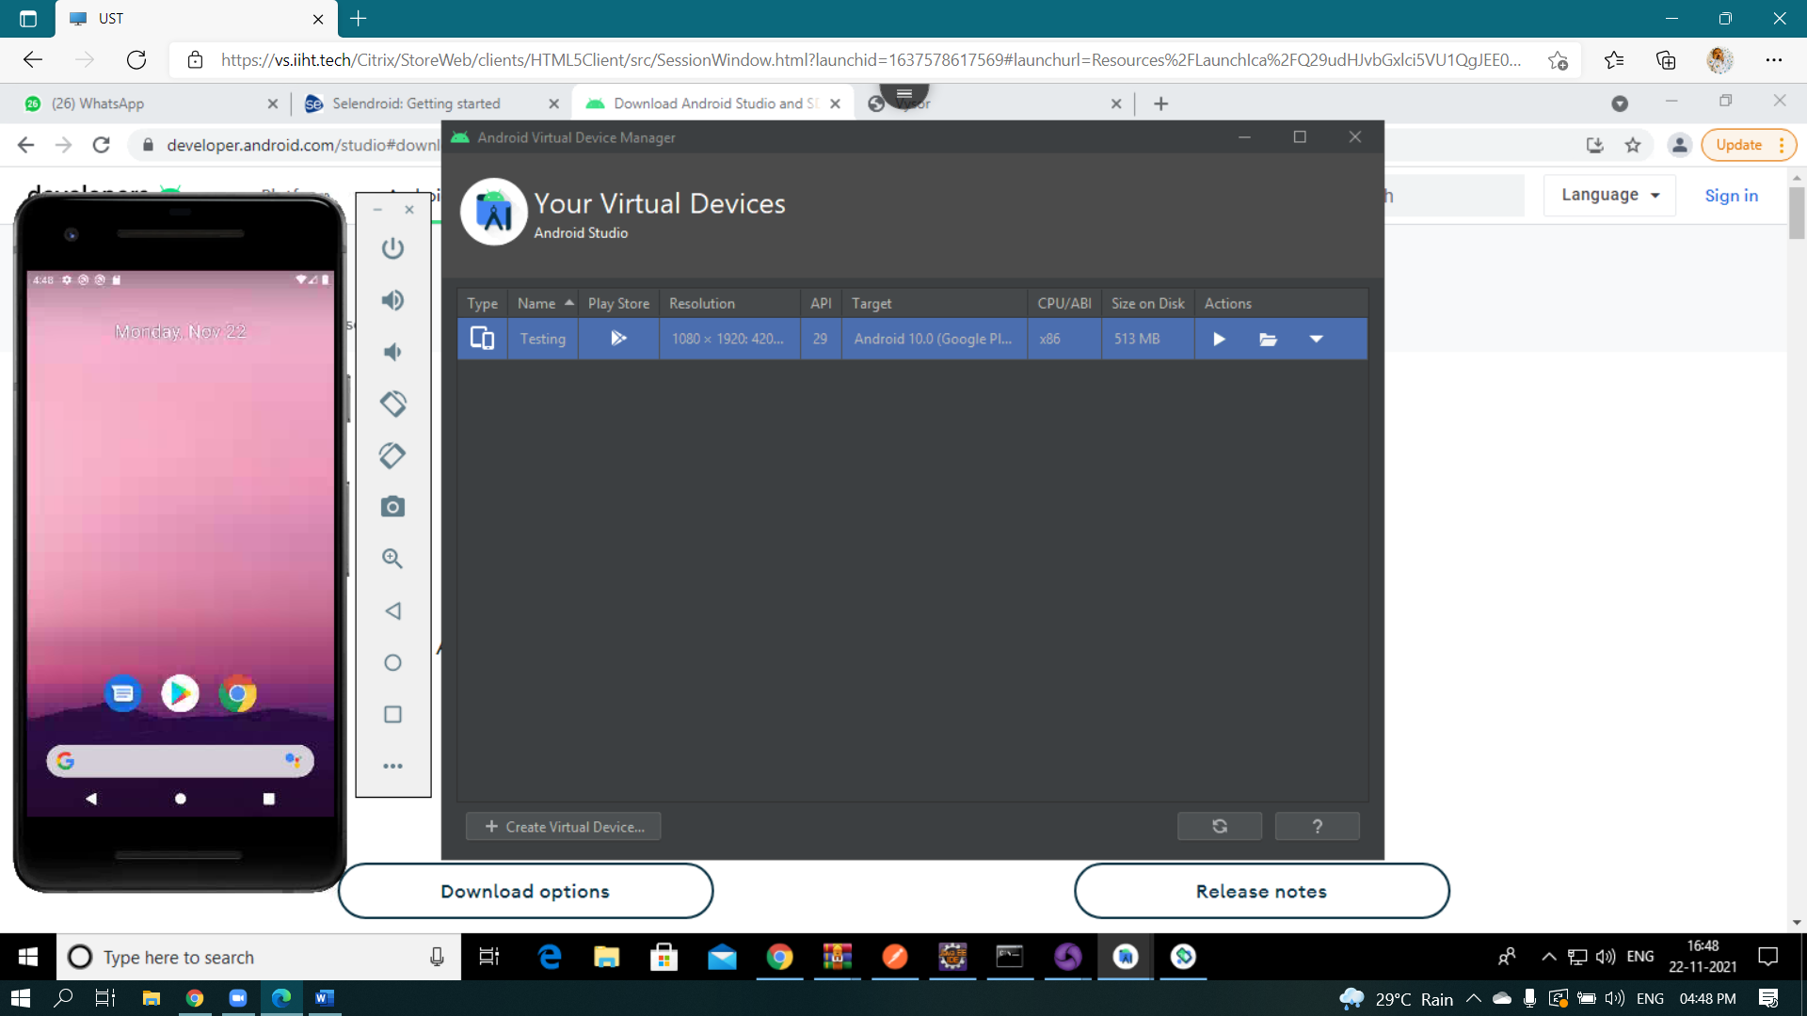

**APPIUM**

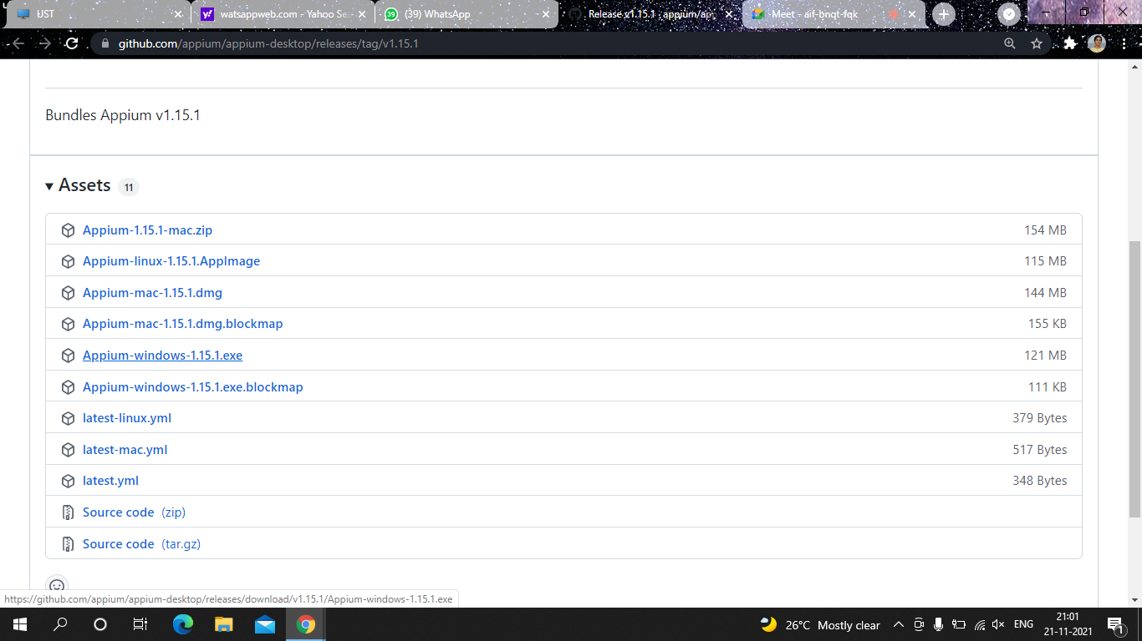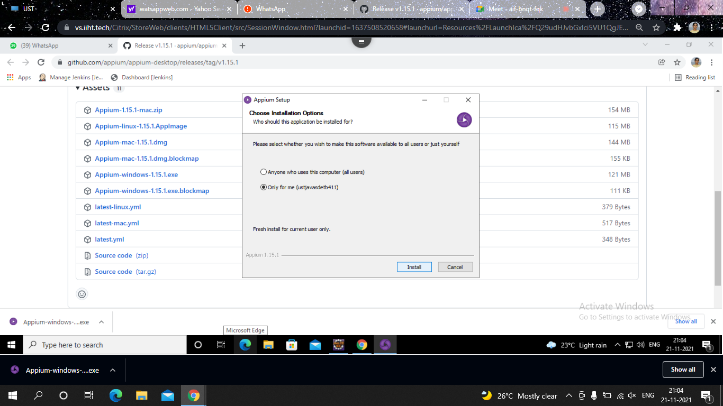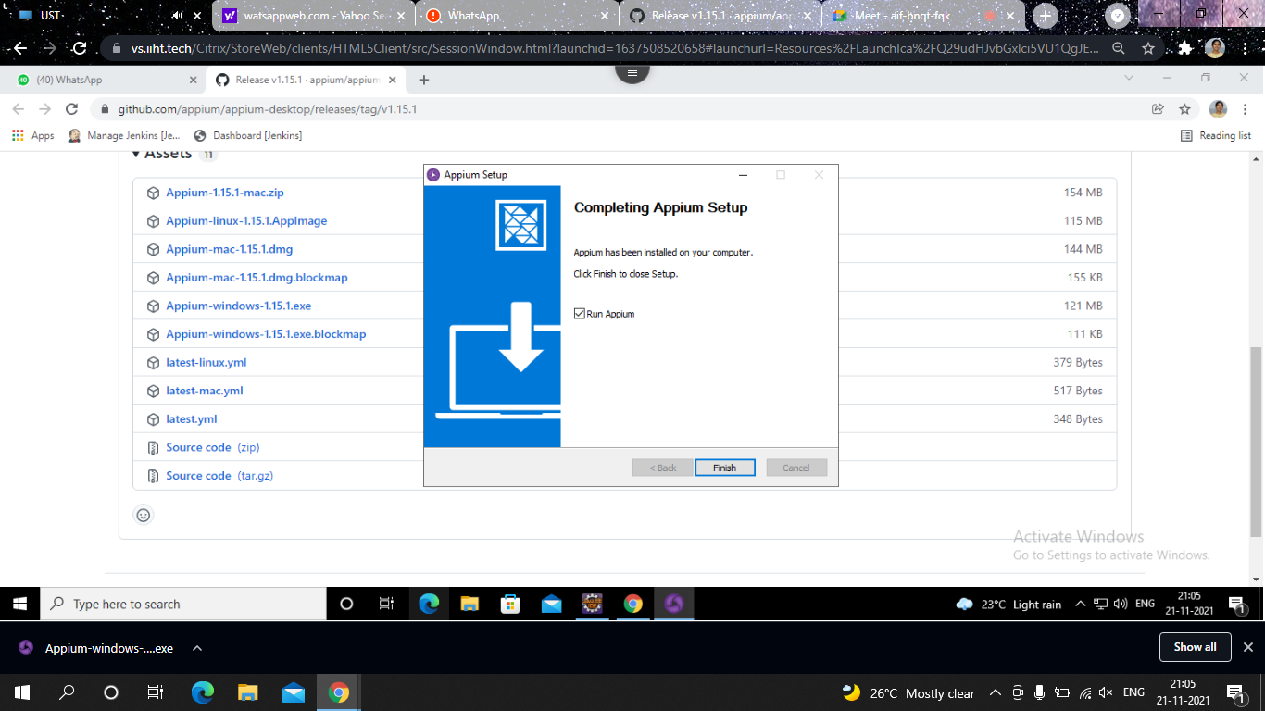

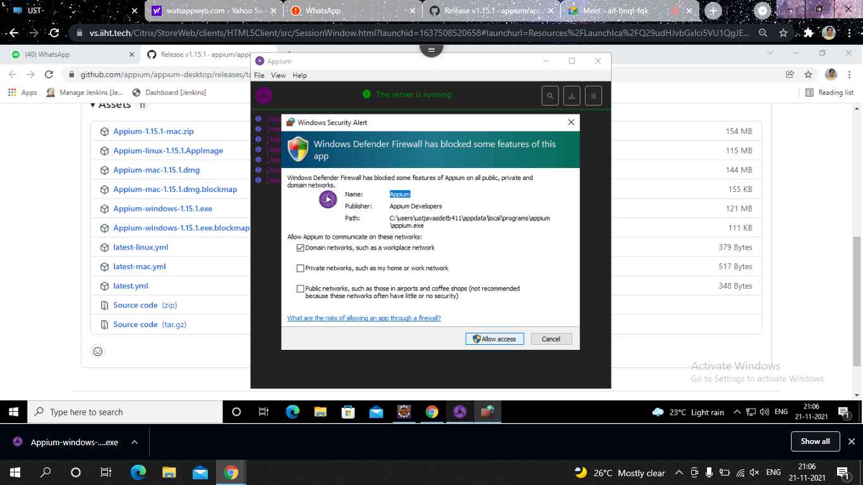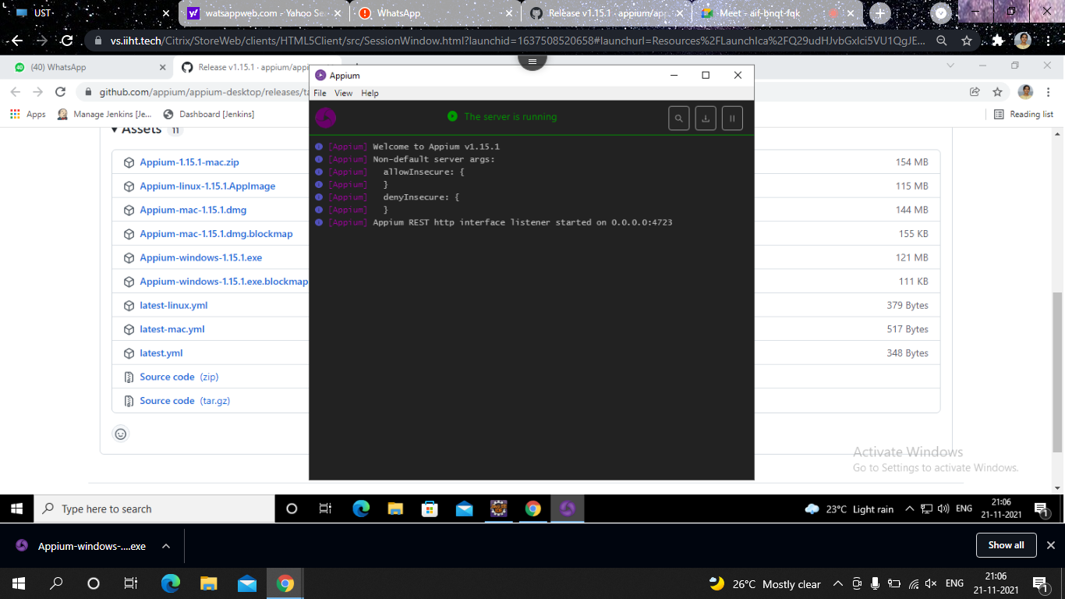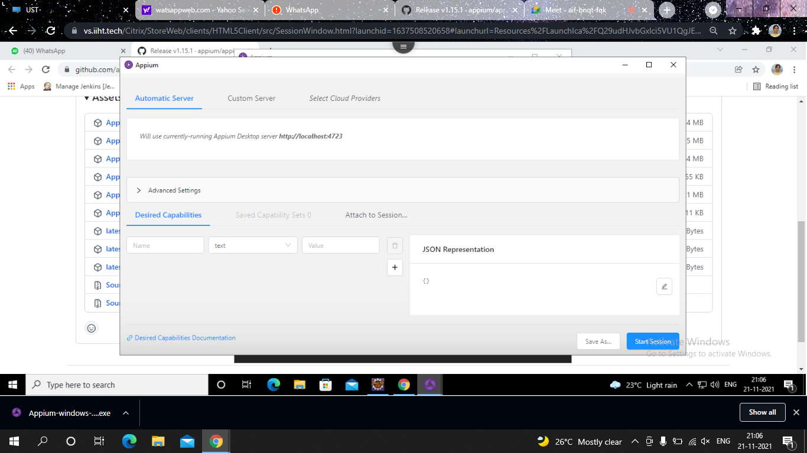

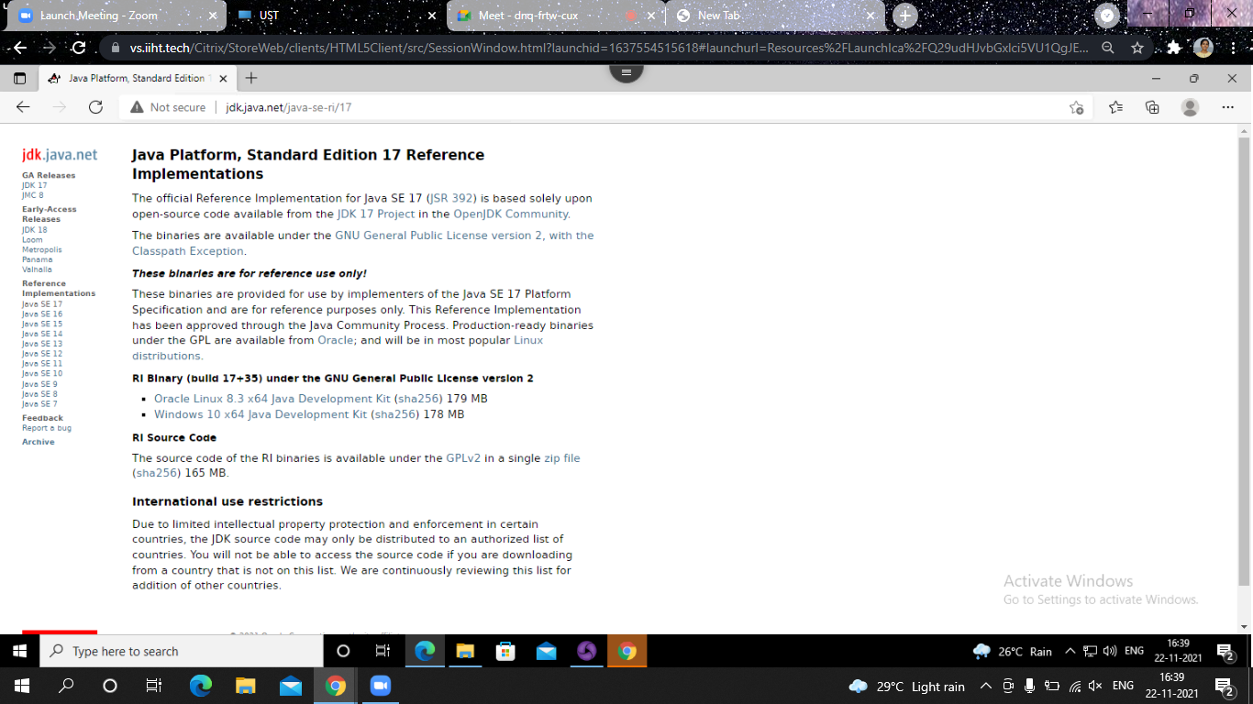

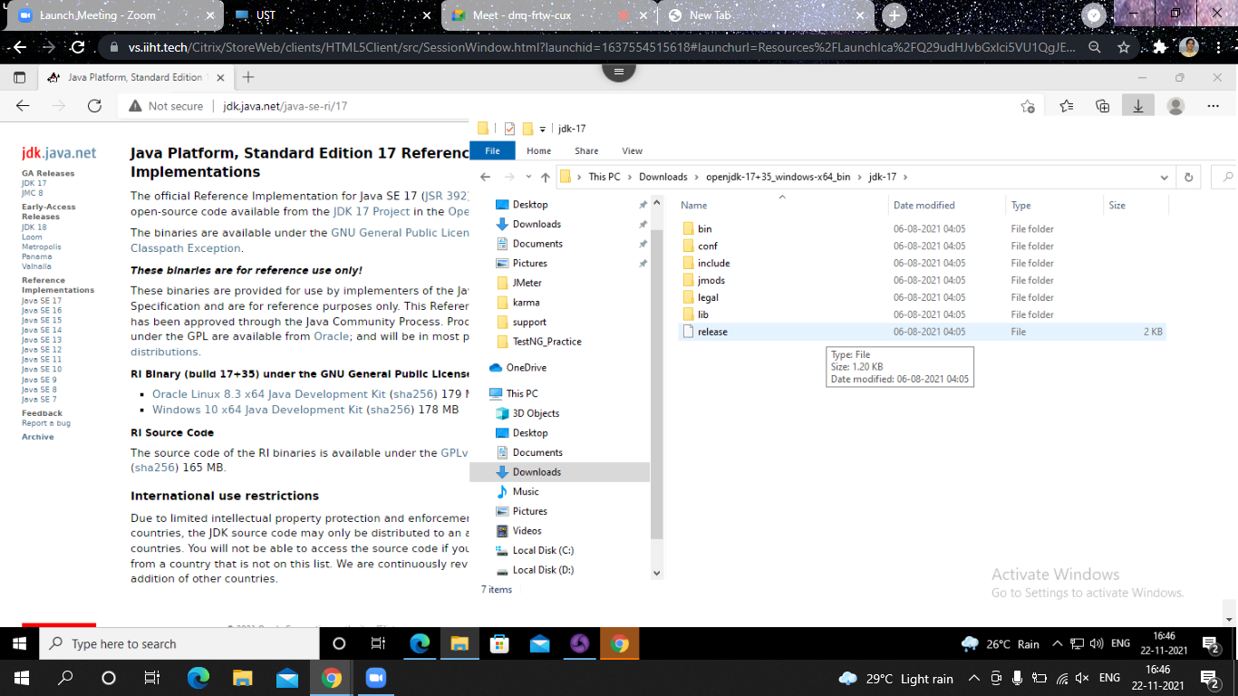

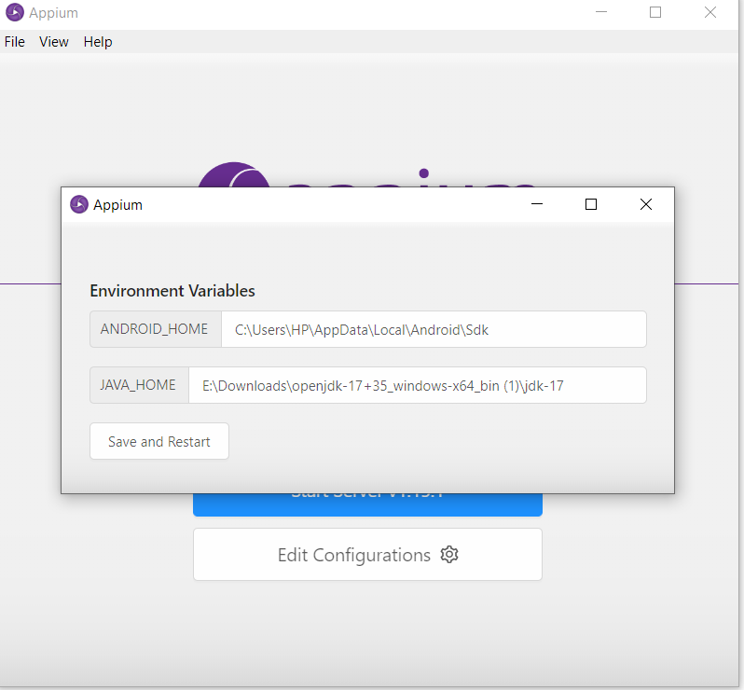

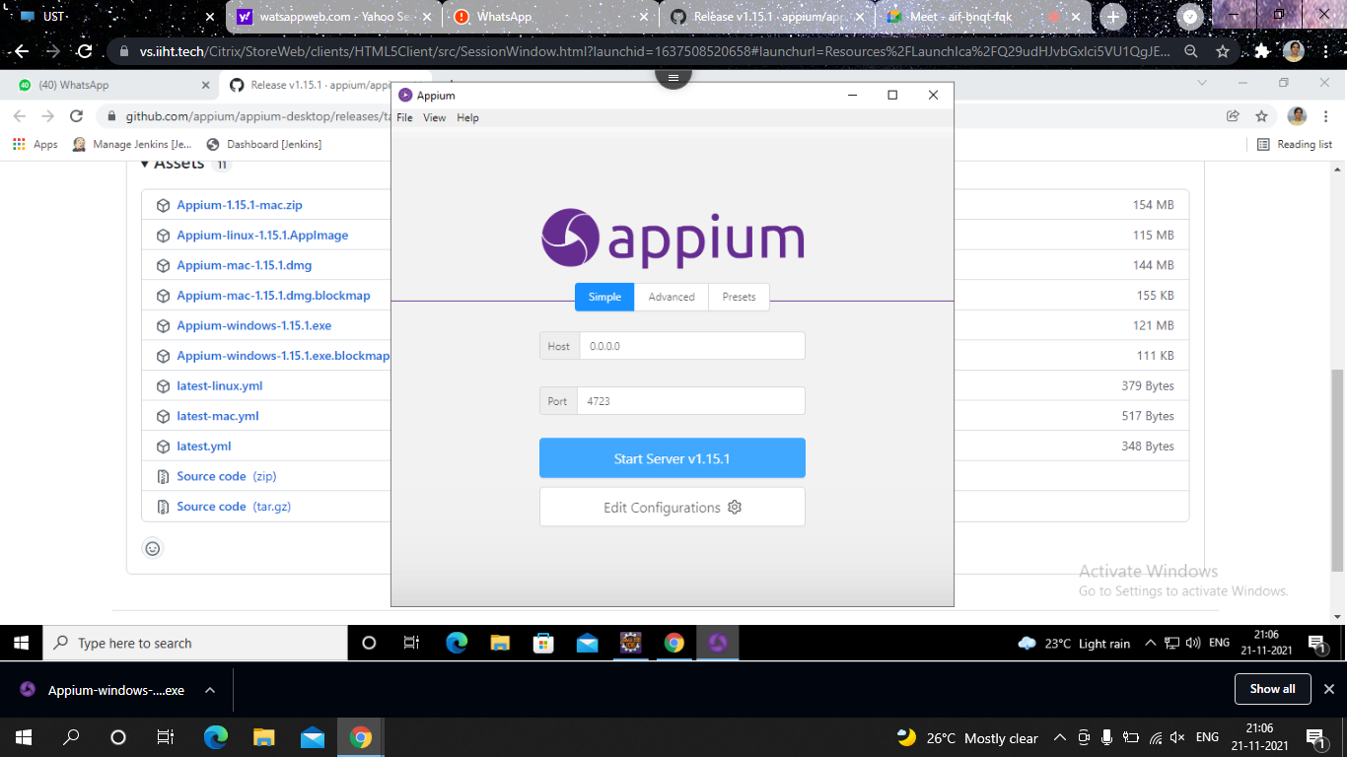

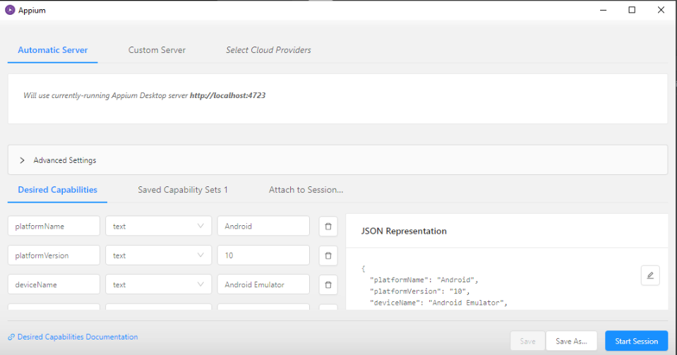

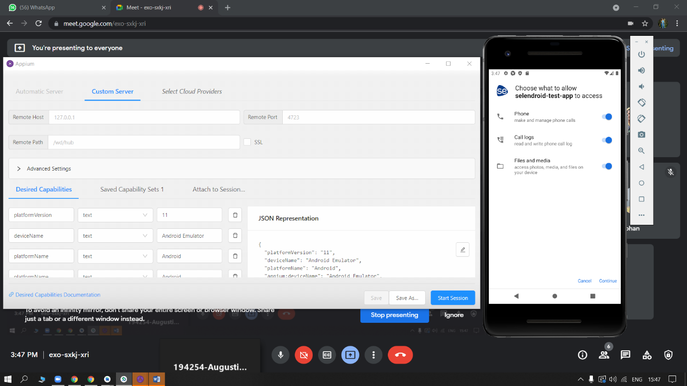

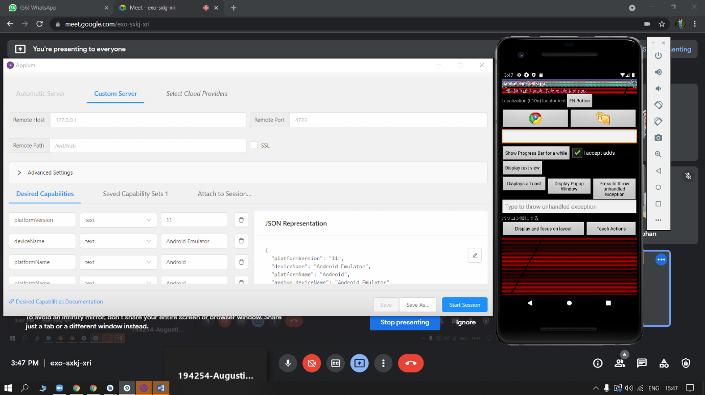

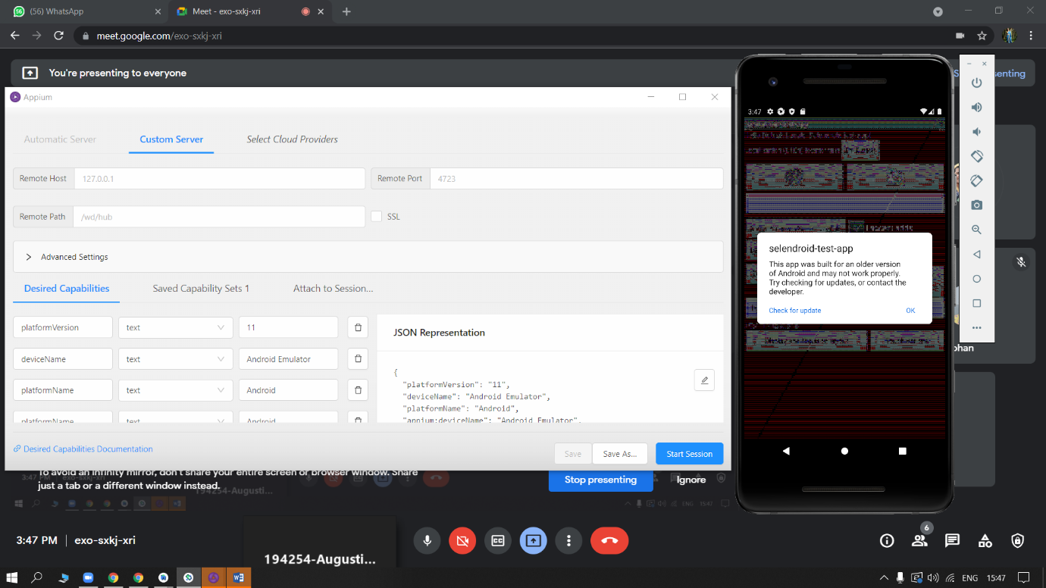

**Edit environment Variable:**

* Add sdk path in System Variable
* Edit path: Add path of platform tools, tools, buildtools\31.1.0
* Set path of android studio

**C:\Users\ustjavasdetb423\AppData\Local\Android\Sdk\platform-tools**

**C:\Users\ustjavasdetb423\AppData\Local\Android\Sdk\tools**

**C:\Program Files\Android\Android Studio\bin**

**C:\Users\ustjavasdetb423\AppData\Local\Android\Sdk\build-tools\31.0.0**

**C:\Users\ustjavasdetb423\Downloads\openjdk-17+35_windows-x64_bin\jdk-17\bin**

**ECLIPSE:**

* Create a maven project

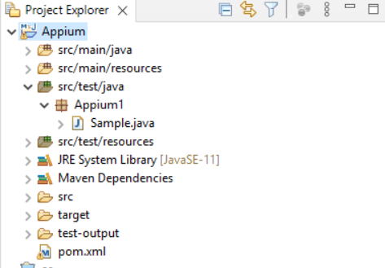

**Code:**

1. **Sample.java**

package Appium1;

import java.net.MalformedURLException;

import java.net.URL;

import java.util.concurrent.TimeUnit;

import org.openqa.selenium.By;

import org.openqa.selenium.WebElement;

import org.openqa.selenium.remote.CapabilityType;

import org.openqa.selenium.remote.DesiredCapabilities;

import org.testng.annotations.Test;

import io.appium.java_client.android.AndroidDriver;

public class Sample {

private static AndroidDriver<WebElement> driver;

@Test

public static void main (String[] args) throws MalformedURLException, InterruptedException {

DesiredCapabilities capabilities = new DesiredCapabilities();

capabilities.setCapability(CapabilityType.BROWSER_NAME, "");

capabilities.setCapability("deviceName", "Pixel_2_API_30");

capabilities.setCapability("platformVersion", "11.0");

capabilities.setCapability("platformName", "Android");

capabilities.setCapability("appPackage", "io.selendroid.testapp");

capabilities.setCapability("appActivity", "io.selendroid.testapp.HomeScreenActivity");

capabilities.setCapability("autoGrantPermissions",true);

driver = new AndroidDriver(new URL("http://127.0.0.1:4723/wd/hub"), capabilities);

driver.manage().timeouts().implicitlyWait(5, TimeUnit.SECONDS);

driver.findElement(By.id("com.android.permissioncontroller:id/continue_button")).click();

driver.findElement(By.id("android:id/button1")).click();

driver.findElement(By.xpath("//android.widget.EditText[@content-desc='my_text_fieldCD']")).sendKeys("Mukesh Selenium Appium");

driver.findElement(By.id("io.selendroid.testapp:id/startUserRegistration")).click();

// close the application

// driver.quit();

}}

**pom.xml**

<?xml version="1.0" encoding="UTF-8"?>

<project xmlns="http://maven.apache.org/POM/4.0.0"

xmlns:xsi="http://www.w3.org/2001/XMLSchema-instance"

xsi:schemaLocation="http://maven.apache.org/POM/4.0.0 http://maven.apache.org/xsd/maven-4.0.0.xsd">

<modelVersion>4.0.0</modelVersion>

<groupId>io-appium</groupId>

<artifactId>io-appium</artifactId>

<version>1.0-SNAPSHOT</version>

<build>

<plugins>

<plugin>

<groupId>org.apache.maven.plugins</groupId>

<artifactId>maven-compiler-plugin</artifactId>

<configuration>

<source>11</source>

<target>11</target>

</configuration>

</plugin>

</plugins>

</build>

<dependencies>

<!-- https://mvnrepository.com/artifact/io.appium/java-client -->

<dependency>

<groupId>io.appium</groupId>

<artifactId>java-client</artifactId>

<version>7.5.1</version>

</dependency>

<!-- https://mvnrepository.com/artifact/org.seleniumhq.selenium/selenium-java -->

<dependency>

<groupId>org.seleniumhq.selenium</groupId>

<artifactId>selenium-java</artifactId>

<version>3.141.59</version>

</dependency>

<!-- https://mvnrepository.com/artifact/org.testng/testng -->

<dependency>

<groupId>org.testng</groupId>

<artifactId>testng</artifactId>

<version>7.4.0</version>

<scope>test</scope>

</dependency>

</dependencies>

</project>

* **Run Sample1.java**

**Output in Emulator:-**

